We've finished breaking down everything from call into a full development plan and we're ready to start building. Before we can kick off some of the bigger features, we need some specific information from your side. Once we have these answers we can move forward without any delays.

1. Promotion Level Thresholds
Needed for: Dashboard Producer & Builder progress bars (the two arrows)
For each of the 6 levels below, please fill in:
- How much In Force premium an agent needs to hit (in dollars)
- The time window it applies to (e.g., last 30 days, 60 days, 90 days)
- For the Builder track only — how many active agents they also need on their team
Level | Target Producer: Premium Needed | Target Producer: Time Window | Target Builder: Premium Needed | Builder: Active Agents Needed | Builder: Time Window
Associate (starting level — no requirement) (60%)
Senior Associate
(70%)
Manager (80%)
Senior Manager (90%)
Regional Executive (100%)
Senior Regional Executive (110%)
National Executive (120%)
Senior National Executive (130%)
I’ve included two pictures, one for the producer and one for the builder. In the pictures you’ll also have find a rule for skipping promotion levels.
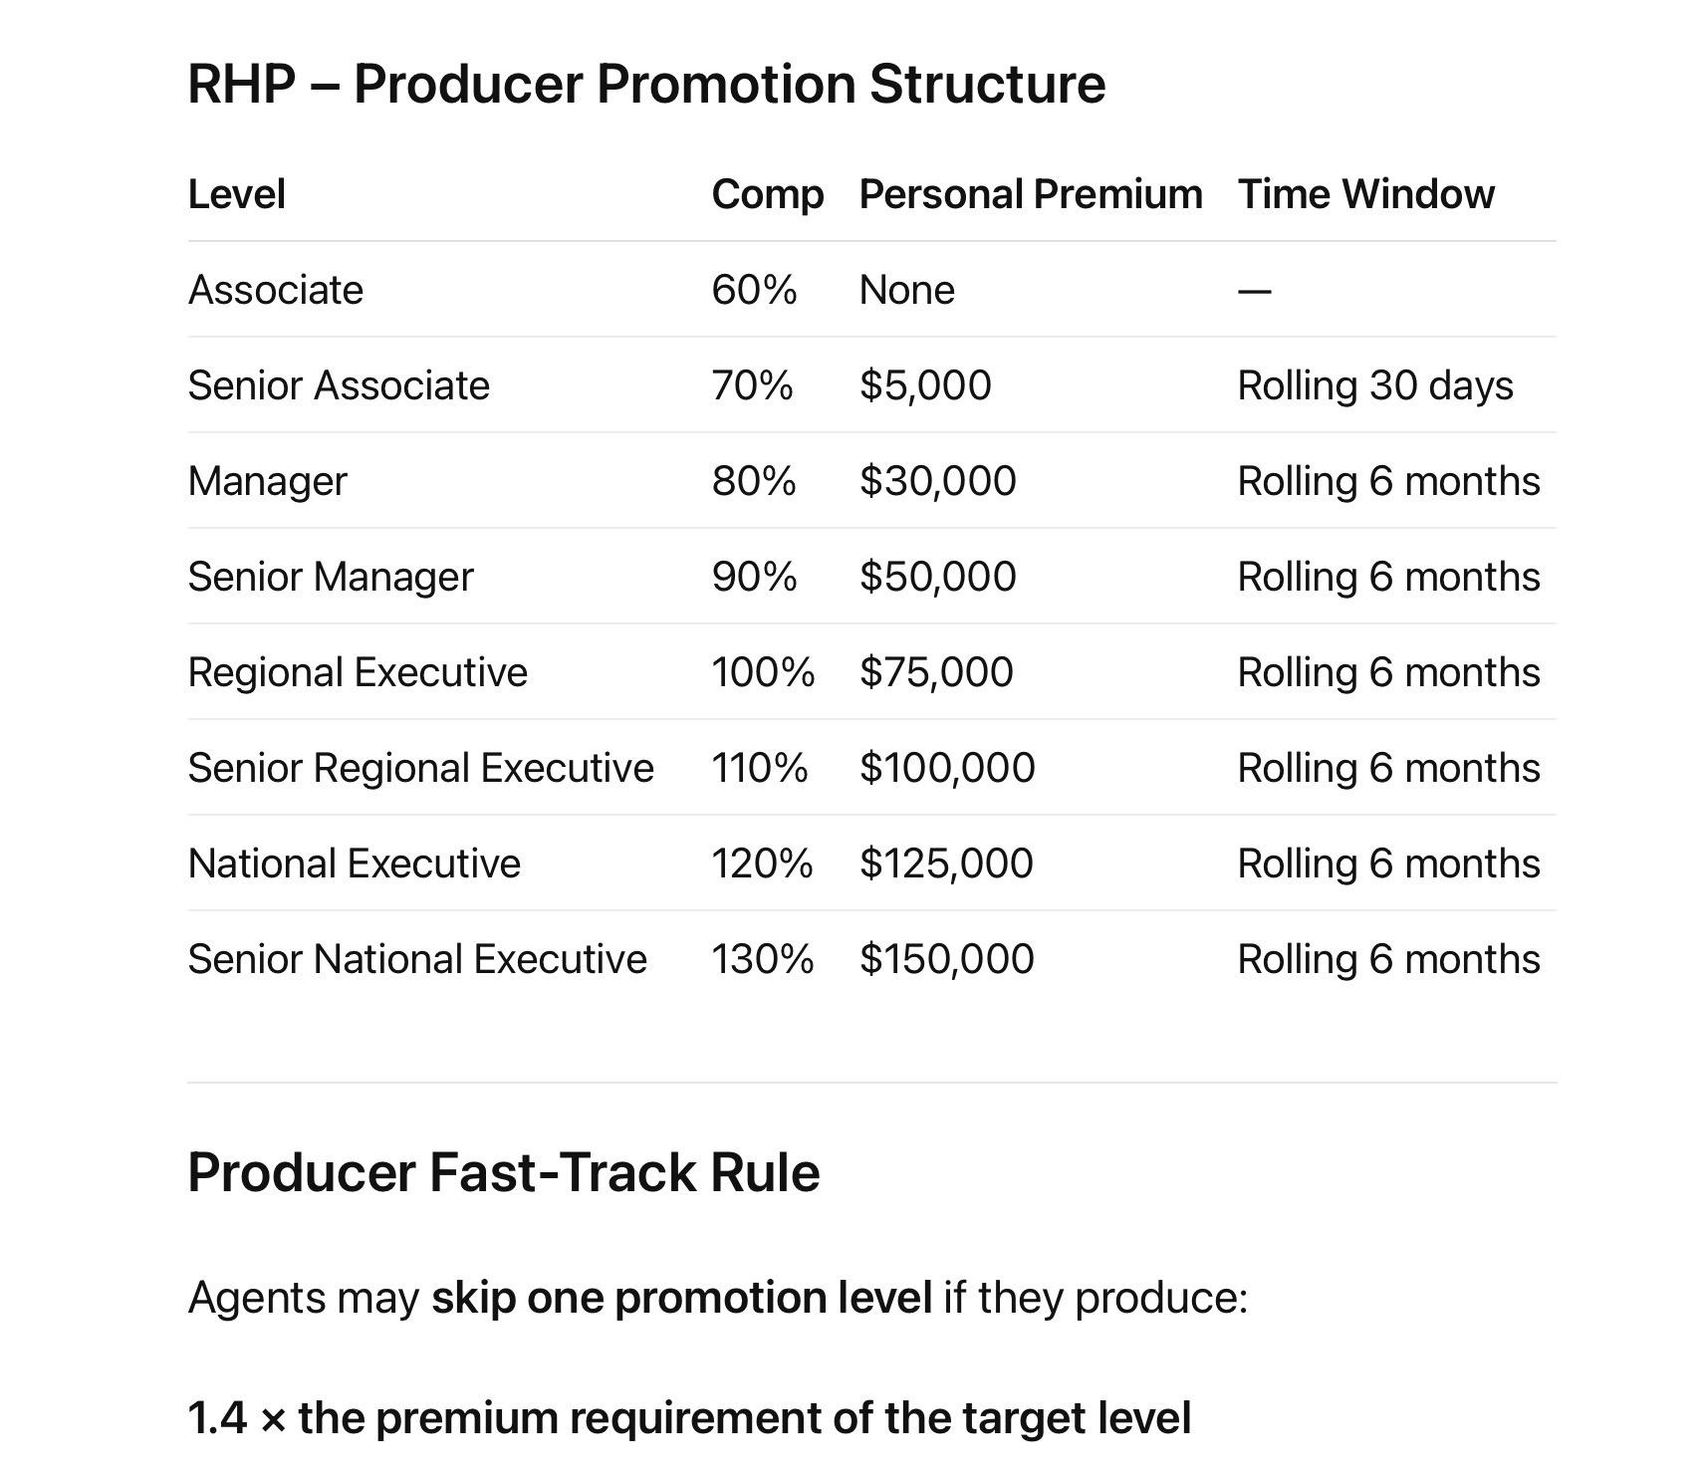

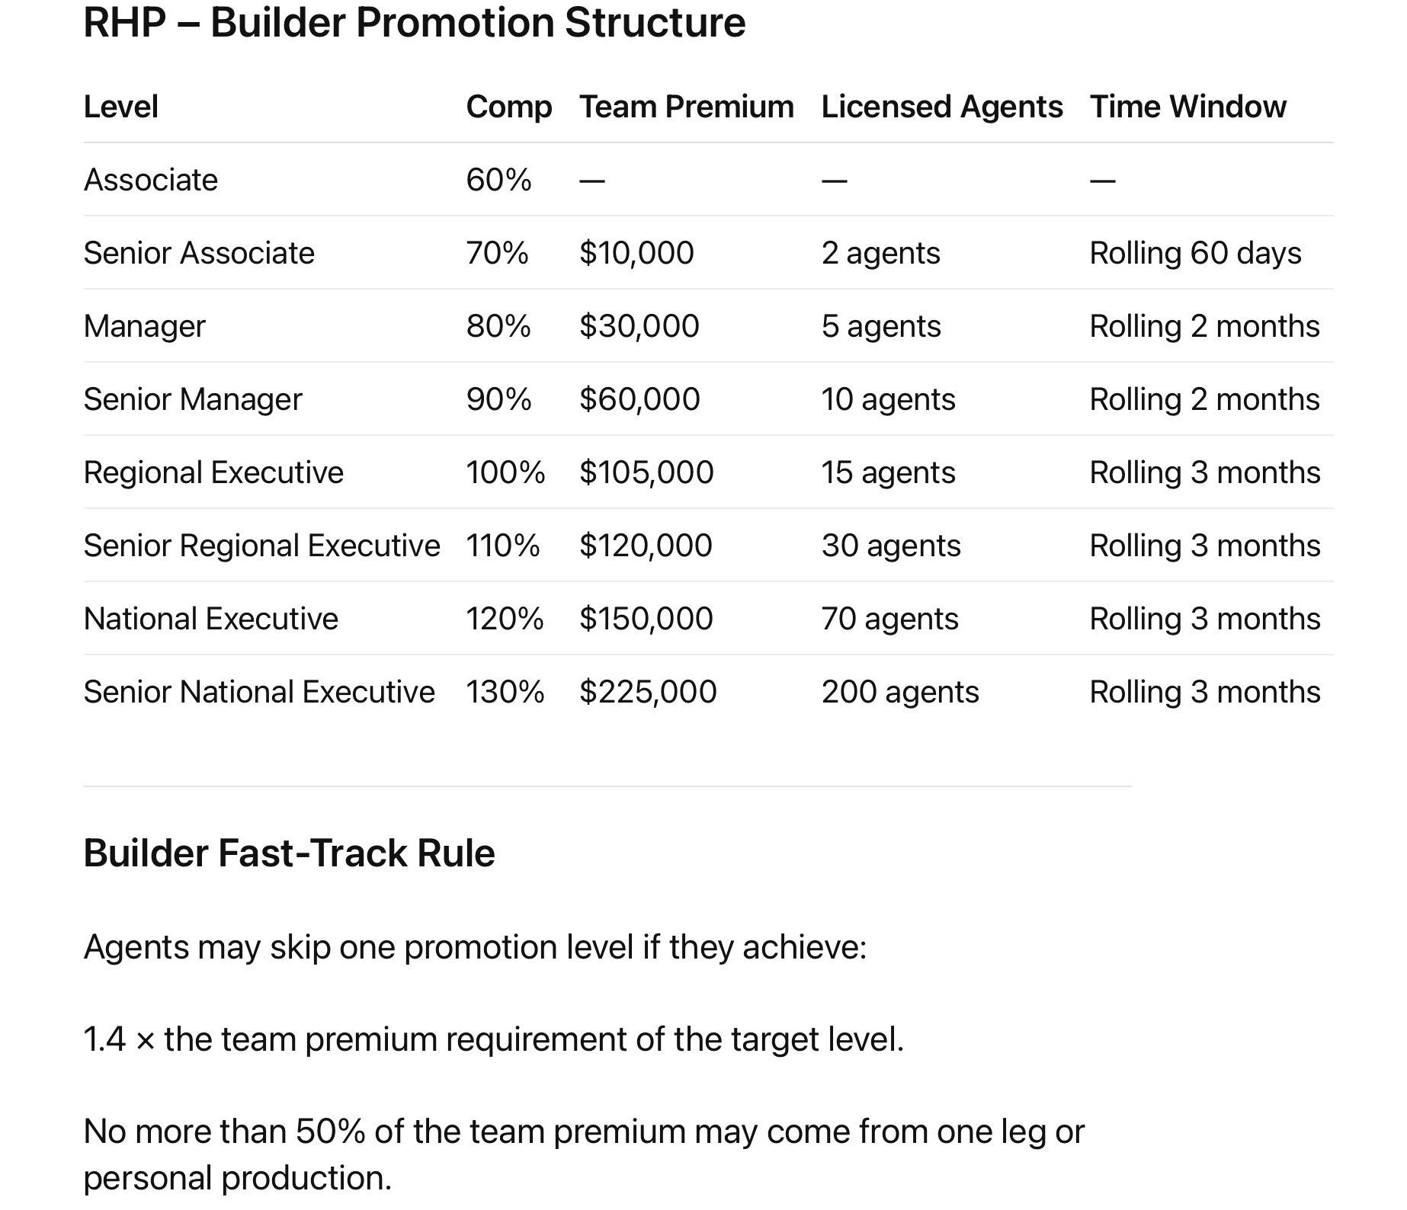

You can also just reply with a simple list like: "Senior Associate = $5,000 in 30 days / Builder: $10,000 + 2 agents in 60 days".

2. Carrier List by Product Category
Needed for: The new 3-tab Carrier Management section (Life & Supplemental / ACA / Medicare)
Life & Supplemental Carriers:
- Trans America — 80%
- American Amicable — 90%
I will upload pictures with factors for each company since each company also has different products.
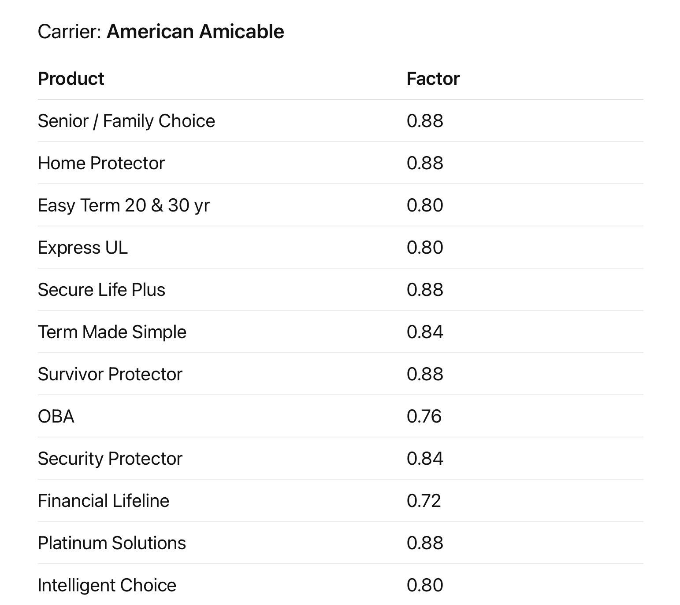
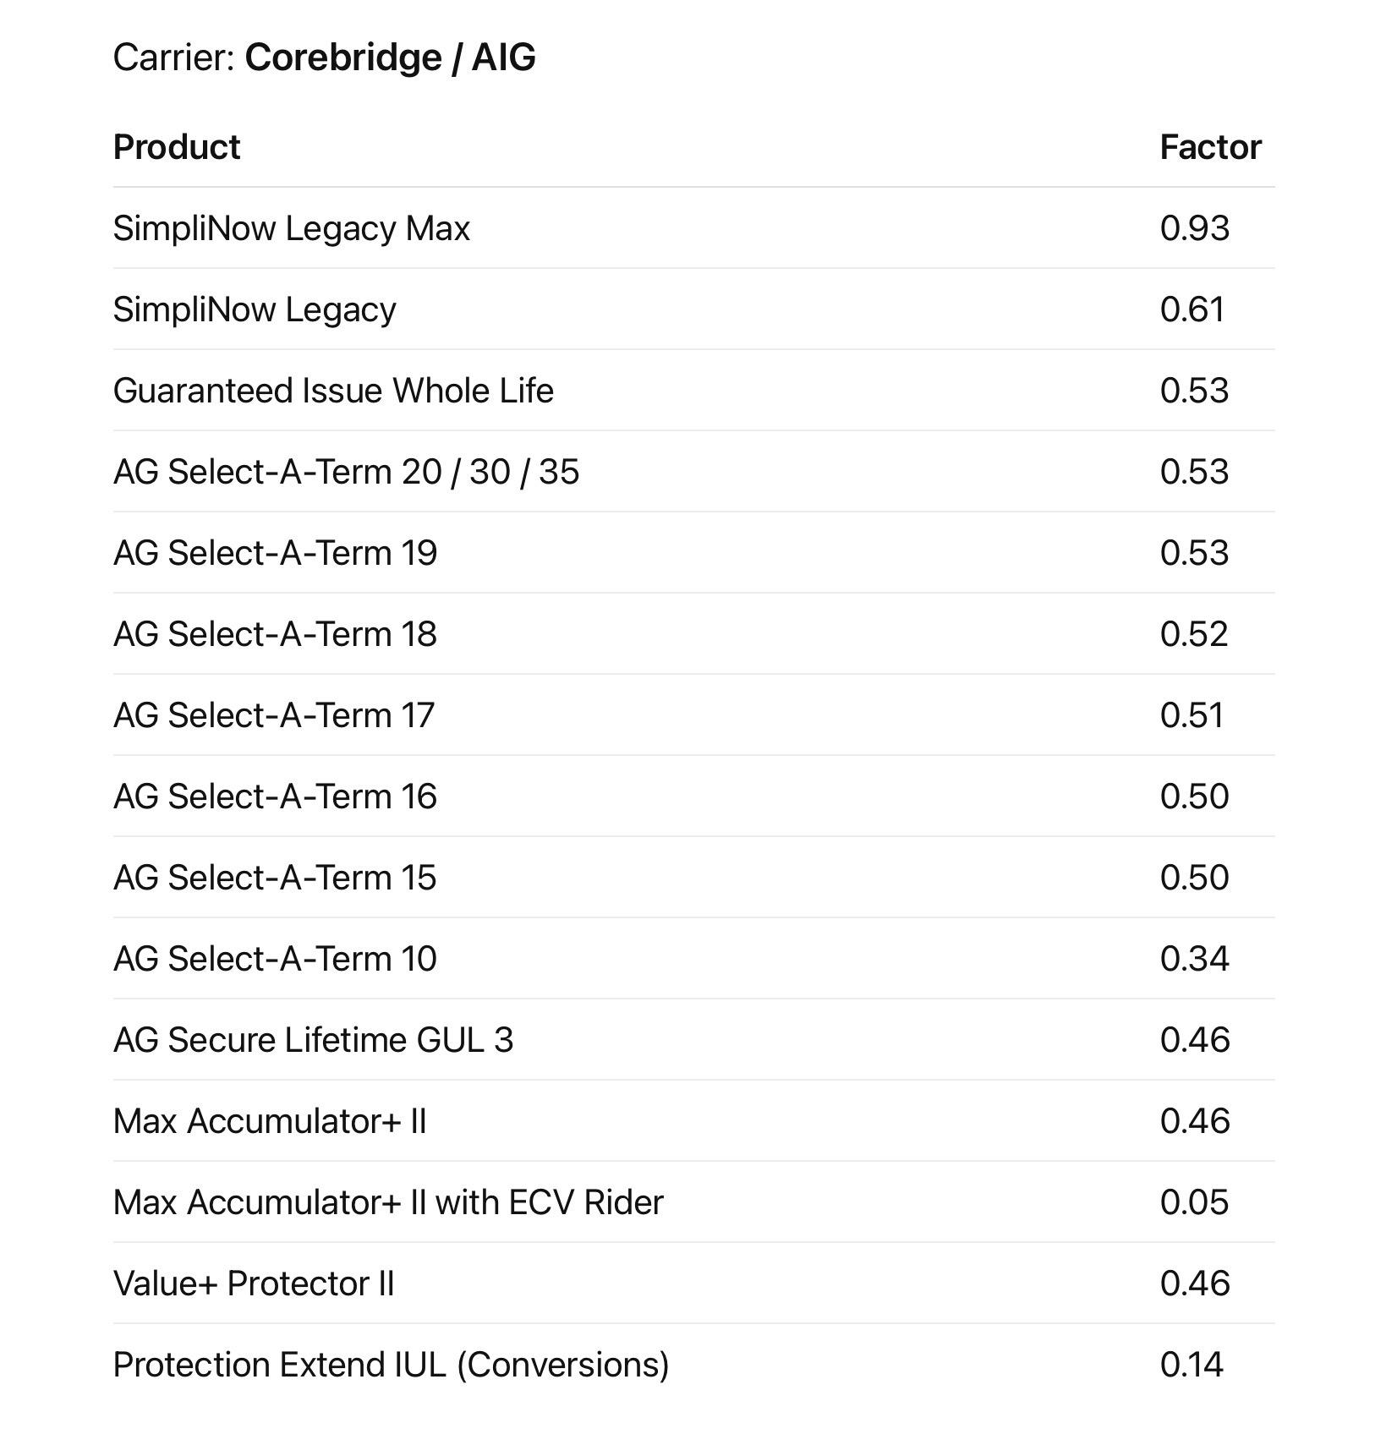
With Assurity it has multiple pages due to the various products and that some are supplemental. For supplemental products I’m also uploading in that tab the guide you see there that has to do with Level 1, level 2, etc. It's a reference for the agent to know based on their title which level of commission they at with supplemental.

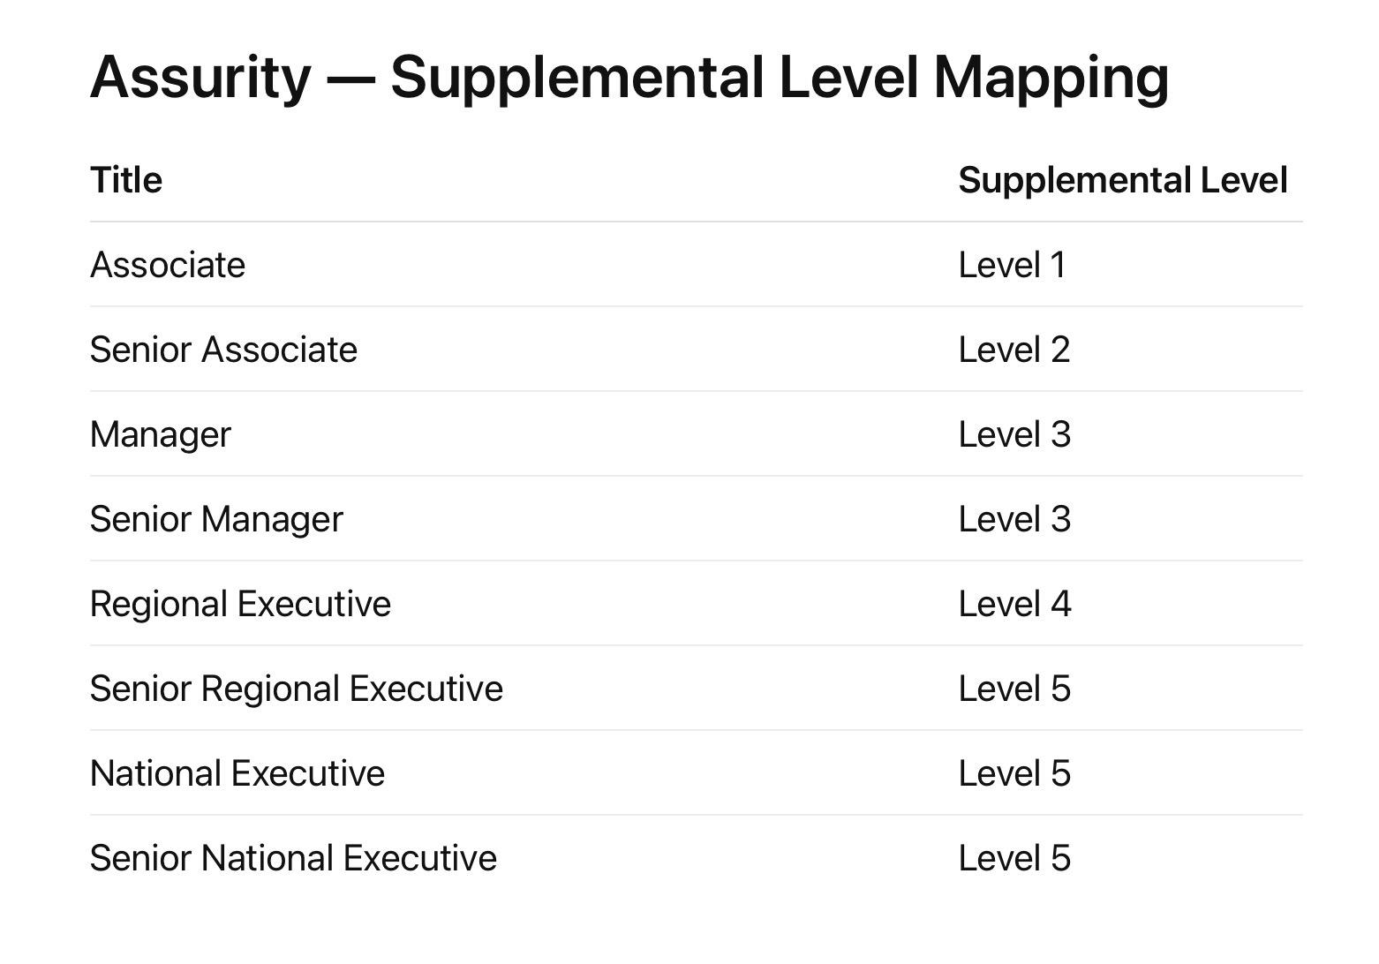
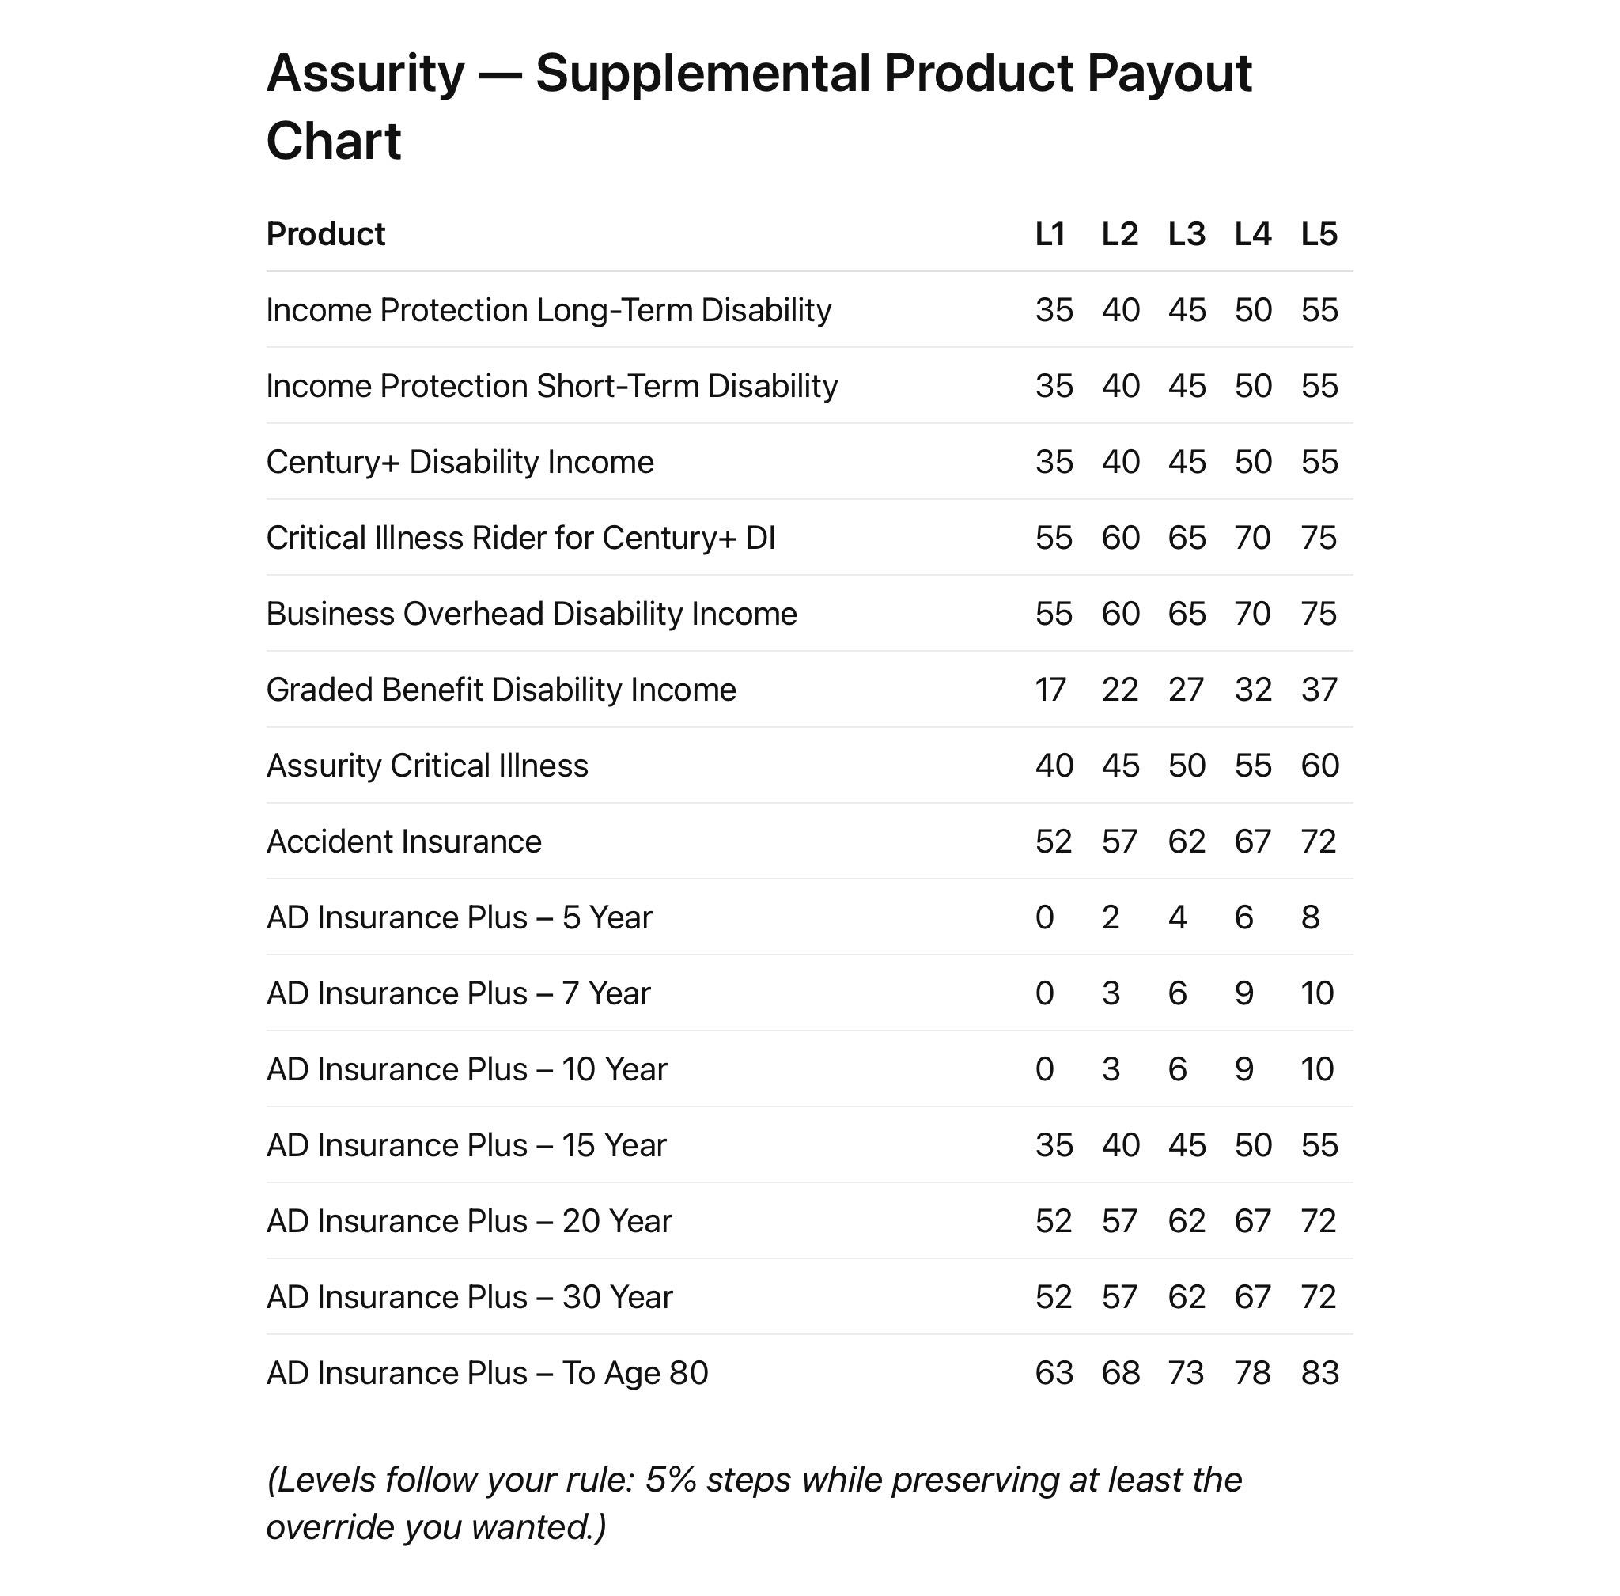
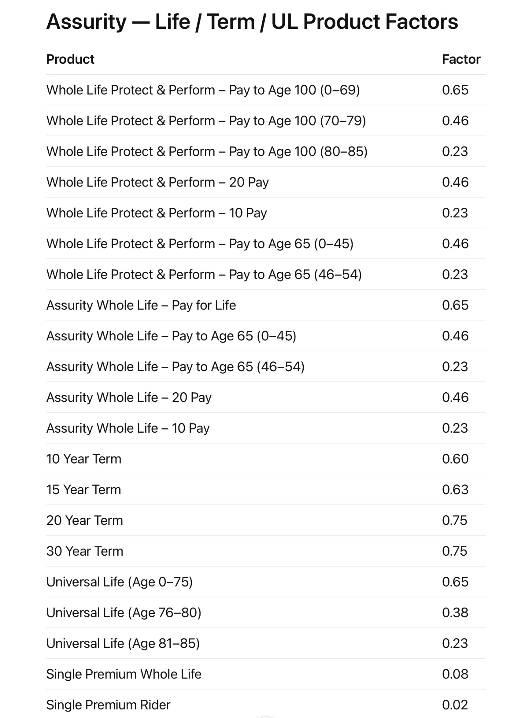

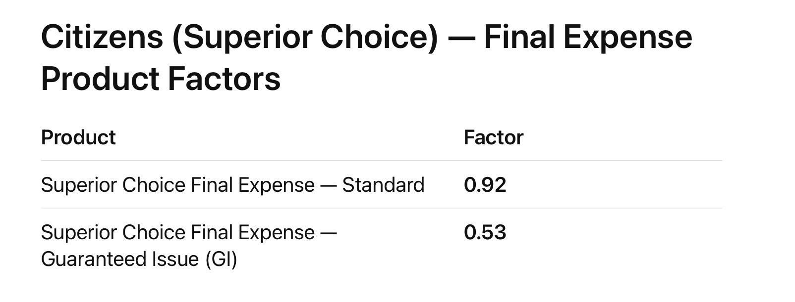
Foresters have a lot of products. There's more than one sheet.
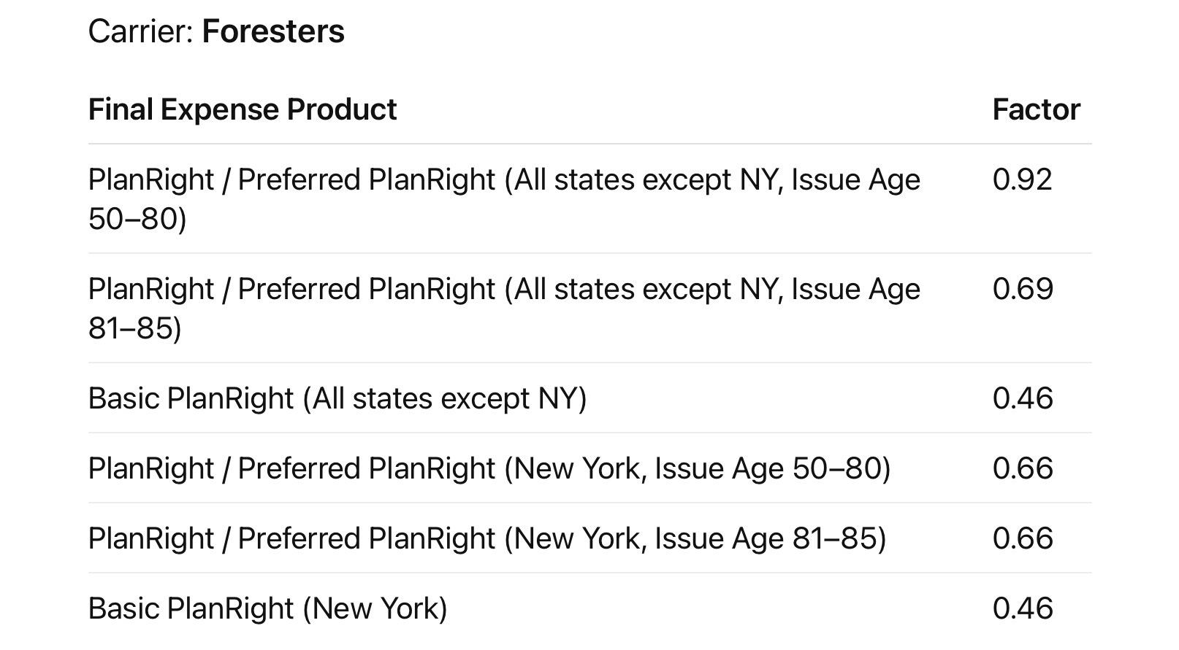
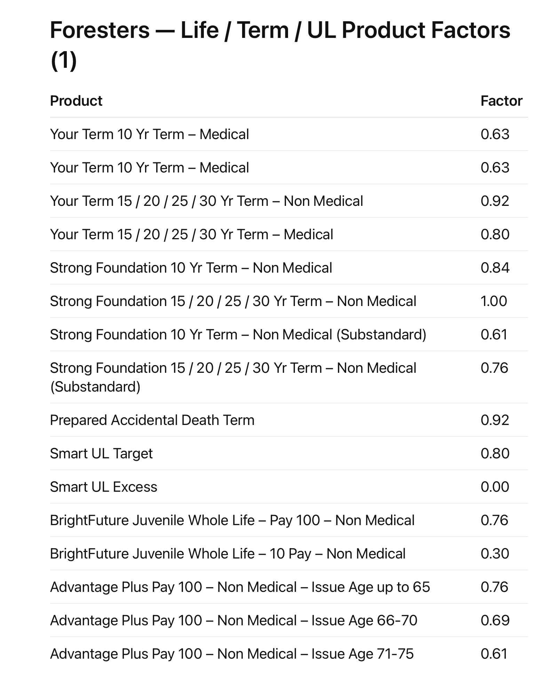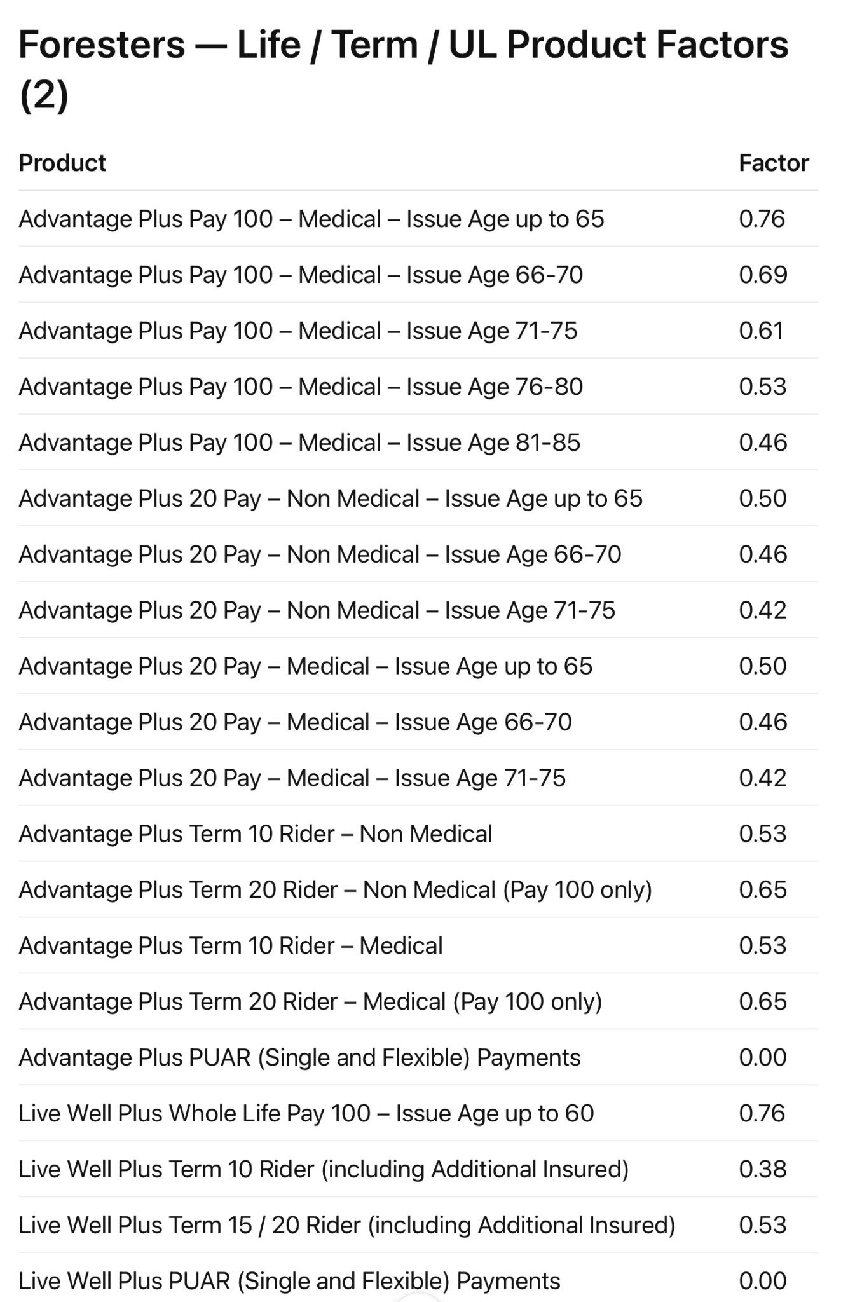
GTL is a supplemental carrier, so like Assurity I’ve included a supplemental level mapping to include in the folder for GTL, and also the commission levels in another picture below.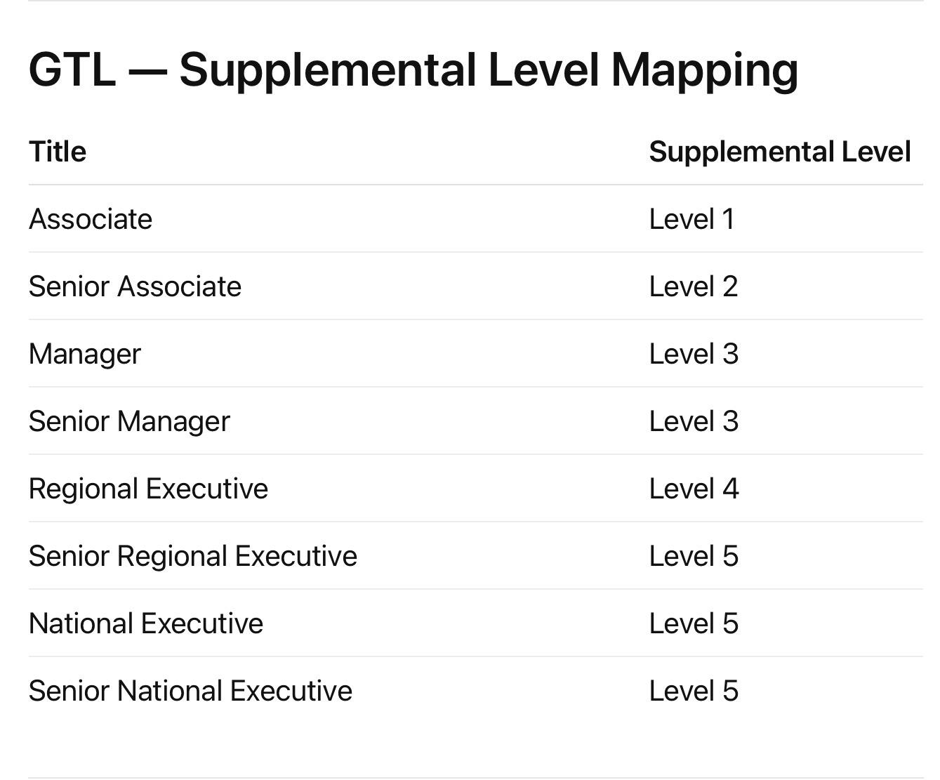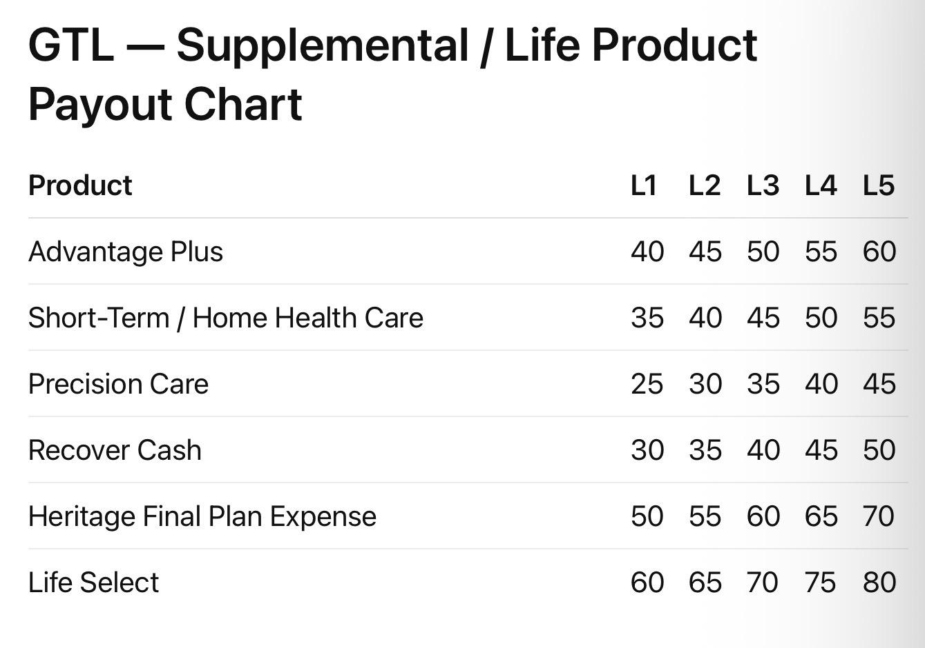
Multiple products with mutual of omaha
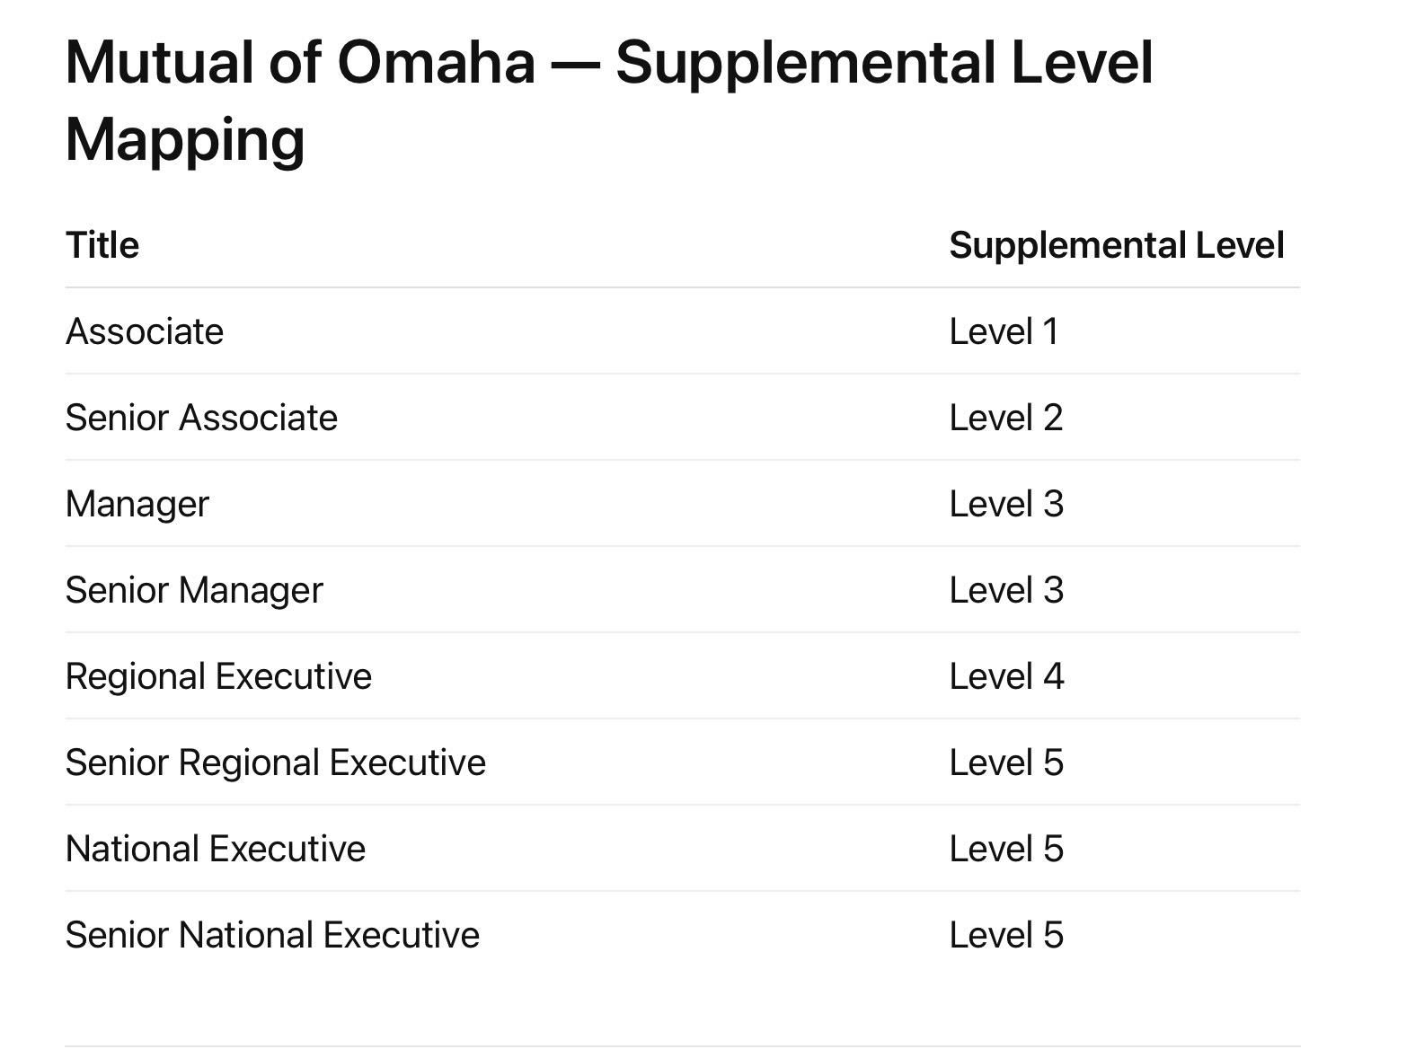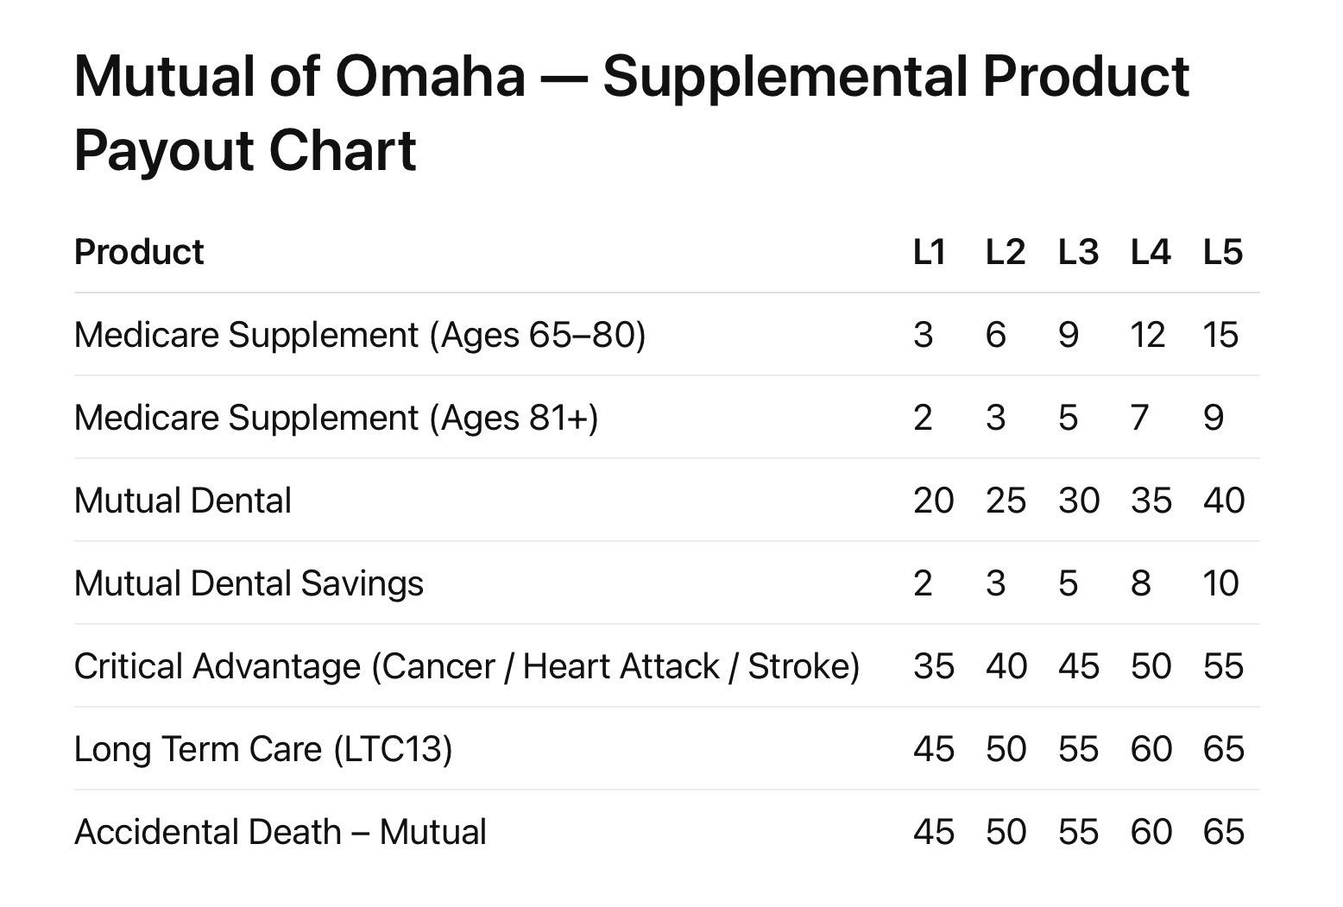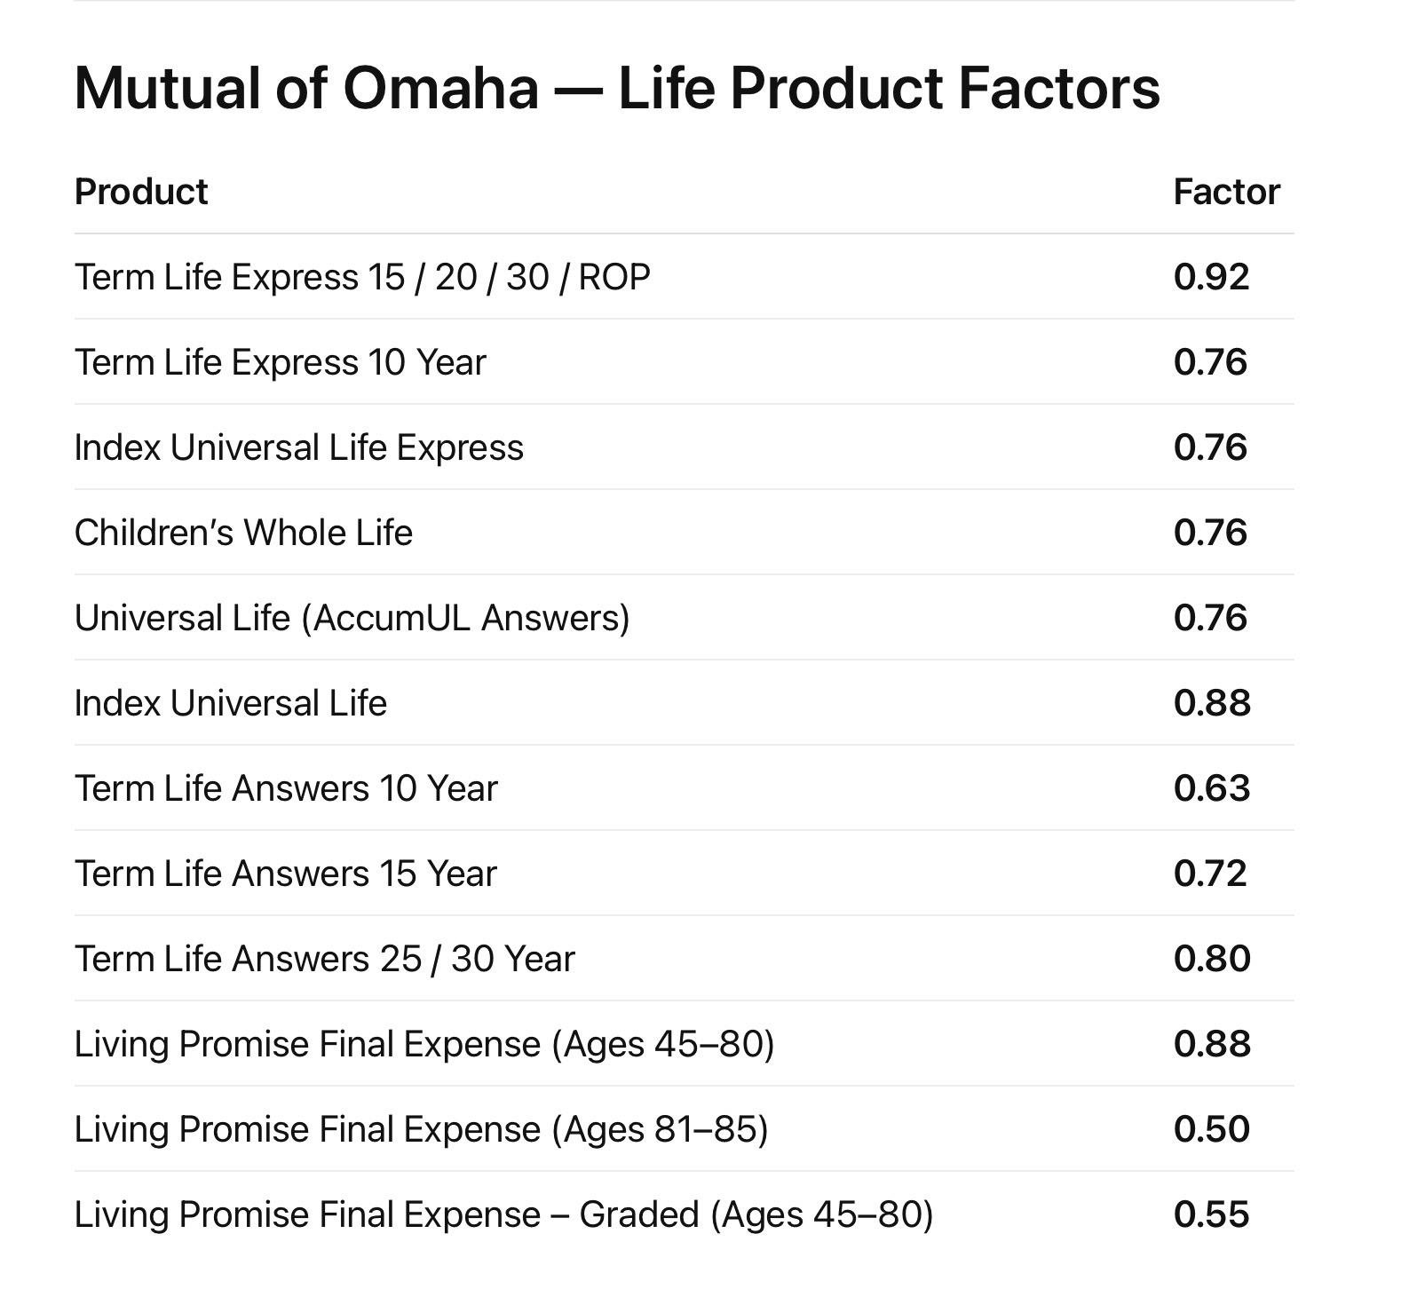
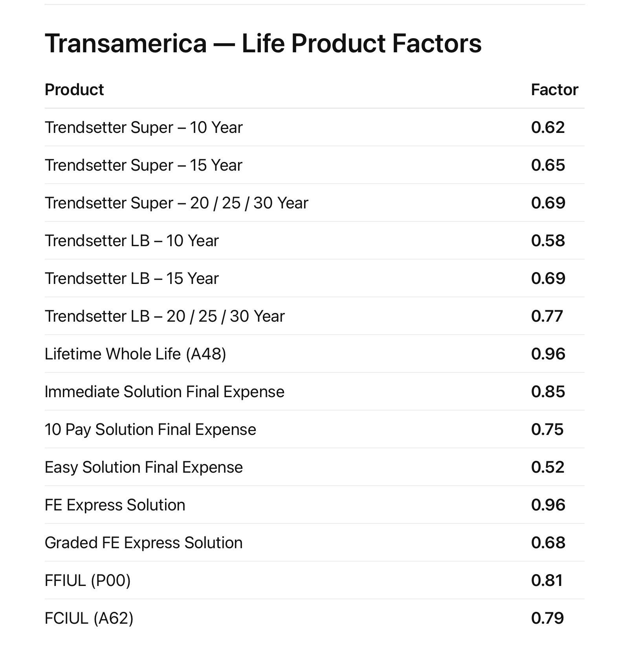
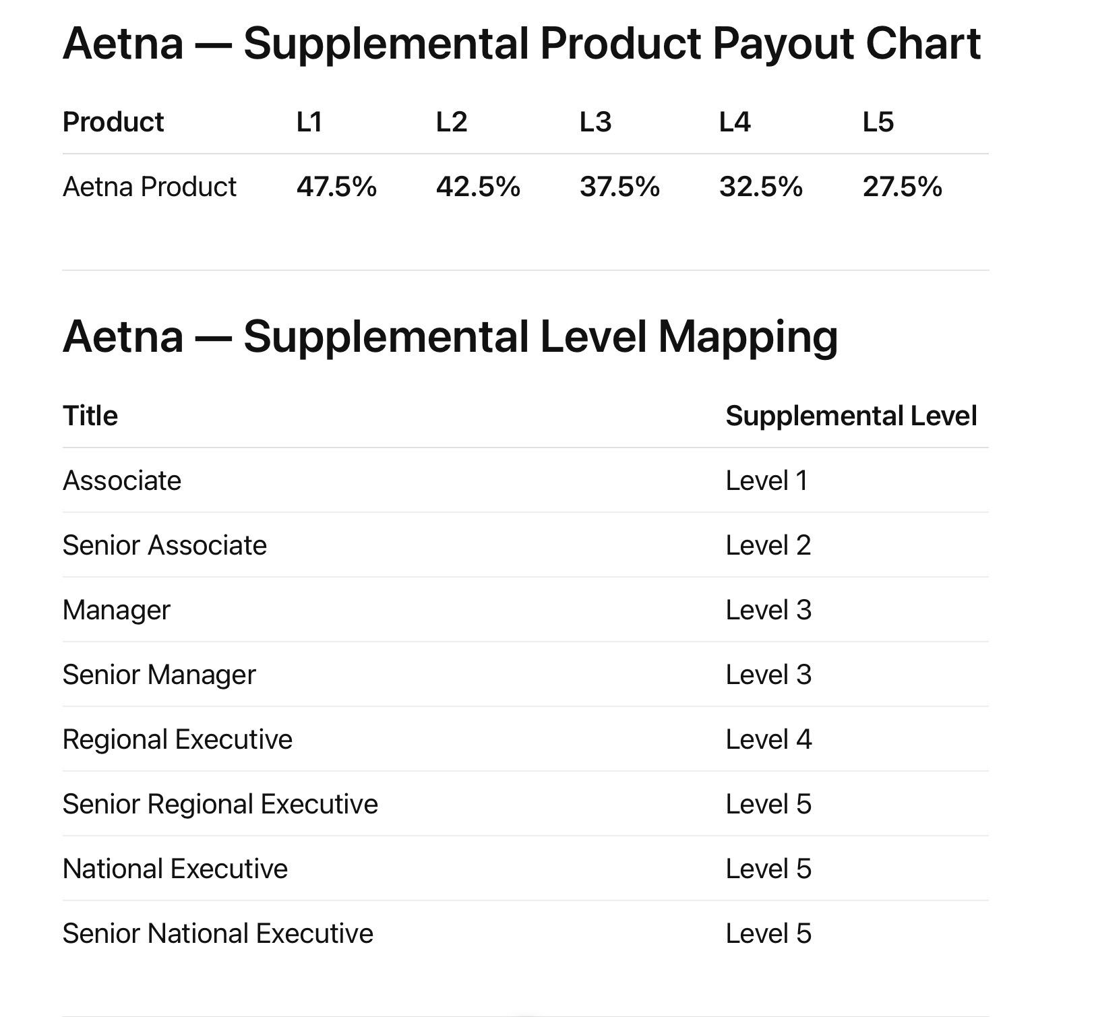

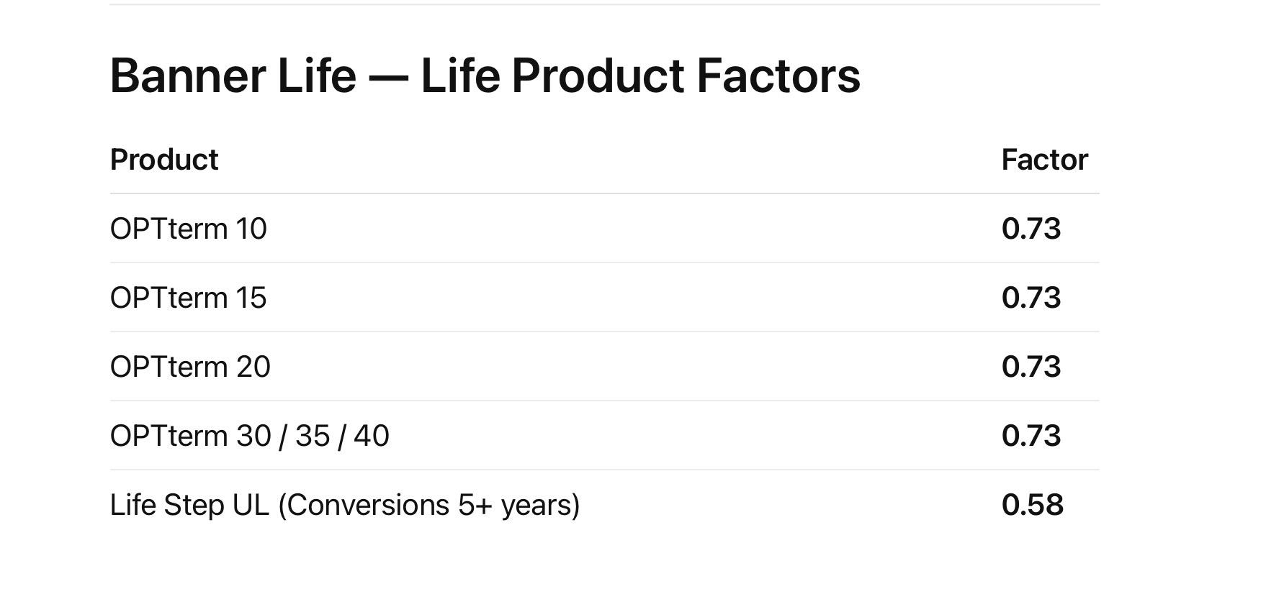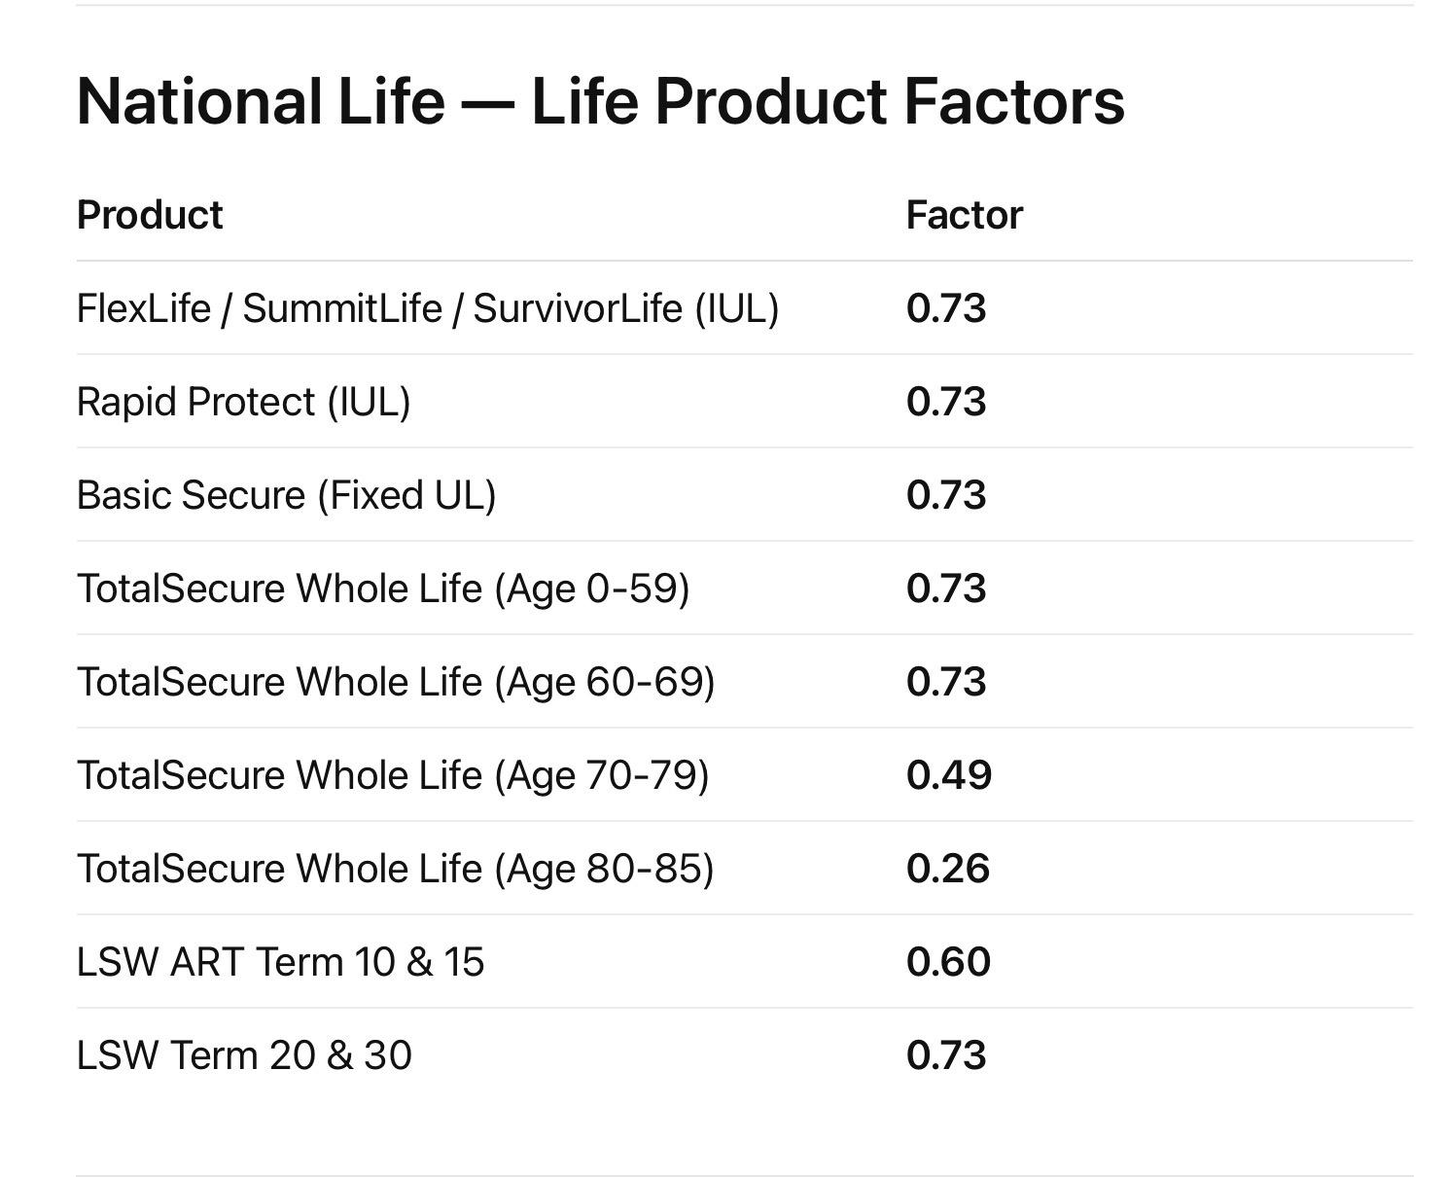

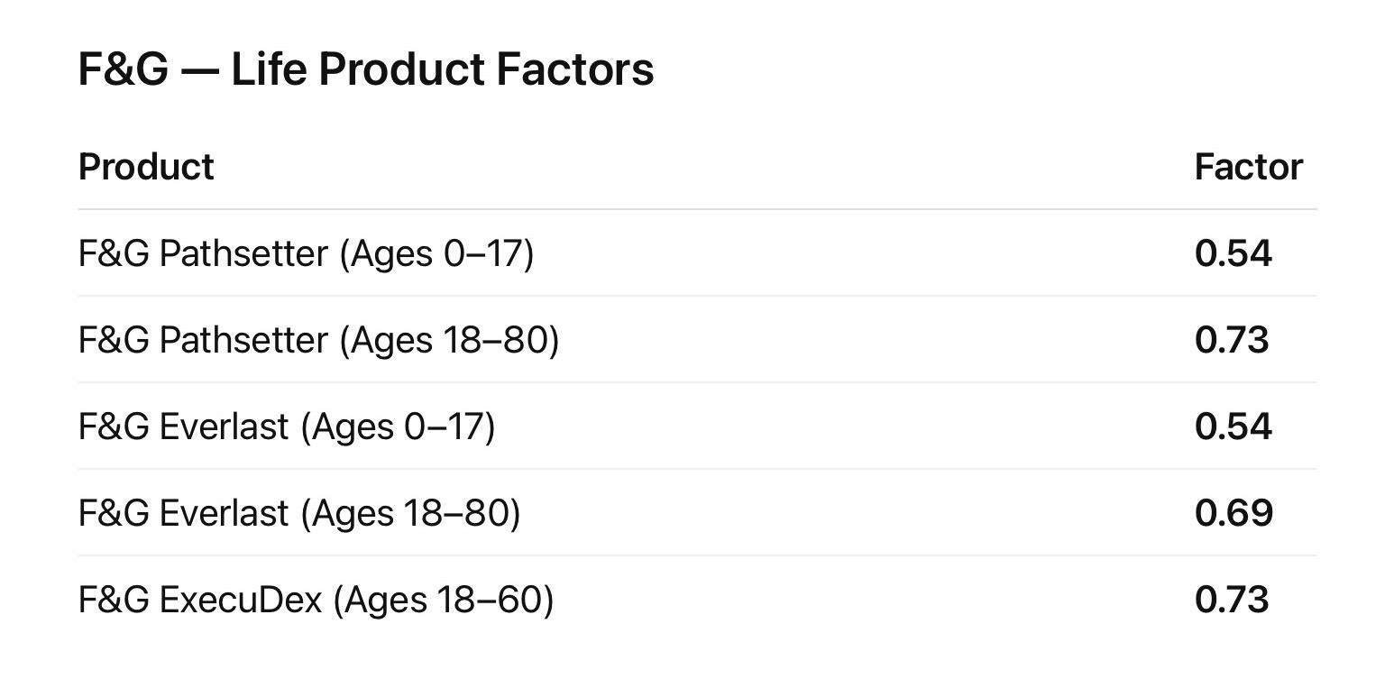

ACA Carriers:
Ambetter (Centene)
Aetna / Aetna CVS Health
Alignment Health Plan
AmeriHealth
Anthem Blue Cross Blue Shield / Elevance Health
AvMed
Blue Cross Blue Shield Plans (state affiliates)
Blue Shield of California
CareSource
Capital BlueCross
Celtic Insurance Company (Ambetter subsidiaries)
Cigna Healthcare
Community Health Choice
Dean Health Plan
EmblemHealth
Excellus BlueCross BlueShield
Fallon Health
Florida Blue
Harvard Pilgrim Health Care
Health Alliance Medical Plans
Health First Health Plans
Health Net
Highmark Blue Cross Blue Shield
Horizon Blue Cross Blue Shield
Independence Blue Cross
Kaiser Permanente
L.A. Care Health Plan
Medica
MercyCare HMO
Molina Healthcare
MVP Health Care
Neighborhood Health Plan of Rhode Island
Oscar Health
PacificSource Health Plans
Presbyterian Health Plan
Priority Health
Quartz Health Solutions
Regence BlueShield
Sanford Health Plan
Security Health Plan
SelectHealth
Sharp Health Plan
Simply Healthcare / Wellpoint
UCare
UnitedHealthcare
University of Utah Health Plans
Wellmark Blue Cross Blue Shield

Medicare Carriers:
Aetna
Alignment Health
AmeriHealth
AmeriHealth Caritas
Anthem
Asuris Northwest Health
BayCare Plus
Blue Cross Blue Shield
Capital Blue Cross
CareFirst
CareSource
Cigna
Clear Spring Health
Clever Care Health Plan
Clover Health
Devoted Health
Elderplan
EmblemHealth
Essence Healthcare
Excellus
Florida Blue
Freedom Health
Geisinger Health Plan
Health First Health Plans
Highmark
Horizon
Humana
Independence Blue Cross
Jefferson Health Plans
Johns Hopkins Healthcare
Kaiser Permanente
Keystone First VIP Choice
Medica
Medical Mutual
MediGold
MetroPlus Health
Molina Healthcare
Mutual of Omaha
MyTru Advantage
PacificSource
Paramount Elite
Priority Health
Providence Health Plan
Regence
SCAN Health Plan
Sentara Health Plans
Simply Healthcare
Sonder Health
SummaCare
The Health Plan
UCLA Health
UnitedHealthcare
Univera Healthcare
UPMC Health Plan
VillageCareMAX
VNS Health
Wellcare
Wellpoint
Zing Health

3.Product Categories & Product Type
CATEGORIES
Life Insurance
Health Insurance
Medicare
Supplemental Insurance
Retirement / Annuities
Property & Casualty — Personal
Property & Casualty — Commercial

Product Types
Medicare
Medicare Advantage
Medicare Supplement (Medigap)
Medicare Part D (Prescription Drug Plan)
Health Insurance
ACA Marketplace Health Insurance
Private Health Insurance
Short-Term Health Insurance
Life Insurance
Term Life Insurance
Whole Life Insurance
Universal Life (UL)
Indexed Universal Life (IUL)
Final Expense / Burial Insurance
Retirement / Annuities
Fixed Annuities
Indexed Annuities
Supplemental Insurance
Short-Term Disability Insurance
Long-Term Disability Insurance
Dental Insurance
Vision Insurance
Hospital Indemnity
Cancer Insurance
Critical Illness Insurance
Accident Insurance
Long-Term Care Insurance
Property & Casualty — Personal
Auto Insurance
Homeowners Insurance
Renters Insurance
Landlord Insurance
Motorcycle Insurance
RV Insurance
Boat / Watercraft Insurance
Umbrella Insurance
Property & Casualty — Commercial
General Liability Insurance
Workers’ Compensation Insurance
Commercial Property Insurance
Commercial Auto Insurance
Business Owner’s Policy (BOP)
Professional Liability Insurance

4. ACA CSV Upload Format
Needed for: ACA Client Volume Tracker (the widget showing team health insurance client counts)
Each month you'll download a file from your carrier system and upload it into RHP Office. We need to know what columns are in that file so we can build the importer.
Please answer:
- What columns does your export file have? (e.g., Agent Name, Agent Email, Client Count, Month)
- Does it have a unique agent ID column, or just name/email?
- What format is the date/period column? (e.g., "2026-03" or "March 2026")
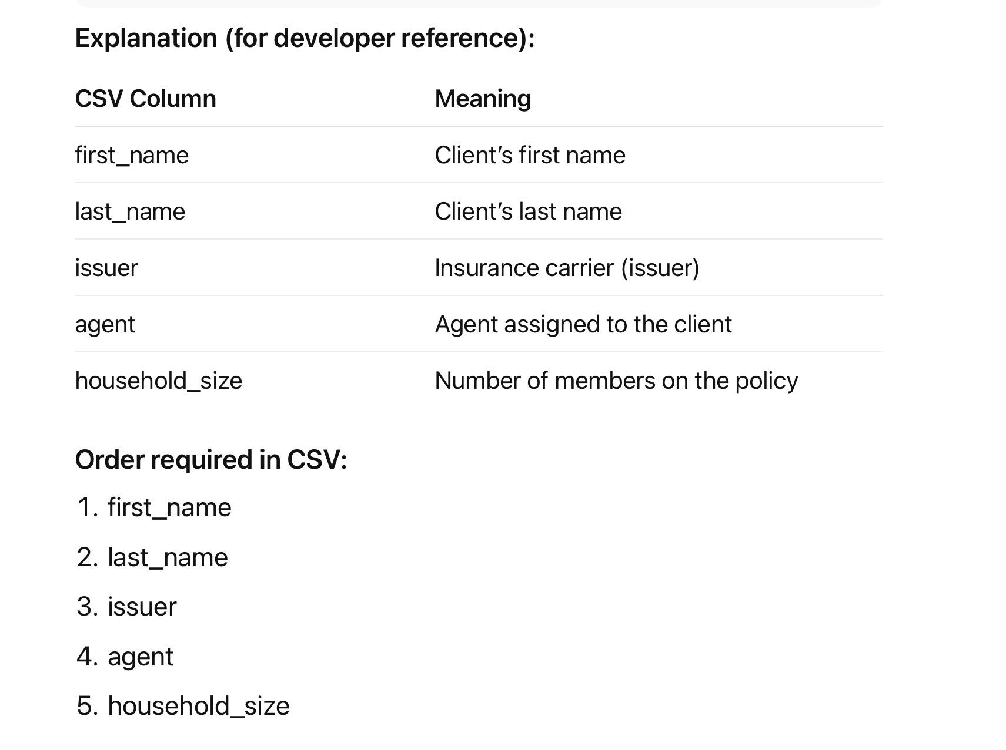

5. Production Submission Statuses — Confirmation
Proposed statuses:
Submitted → Pending → In Force → Lapsed → Cancelled
Does this cover everything? Add additional statuses if needed below:
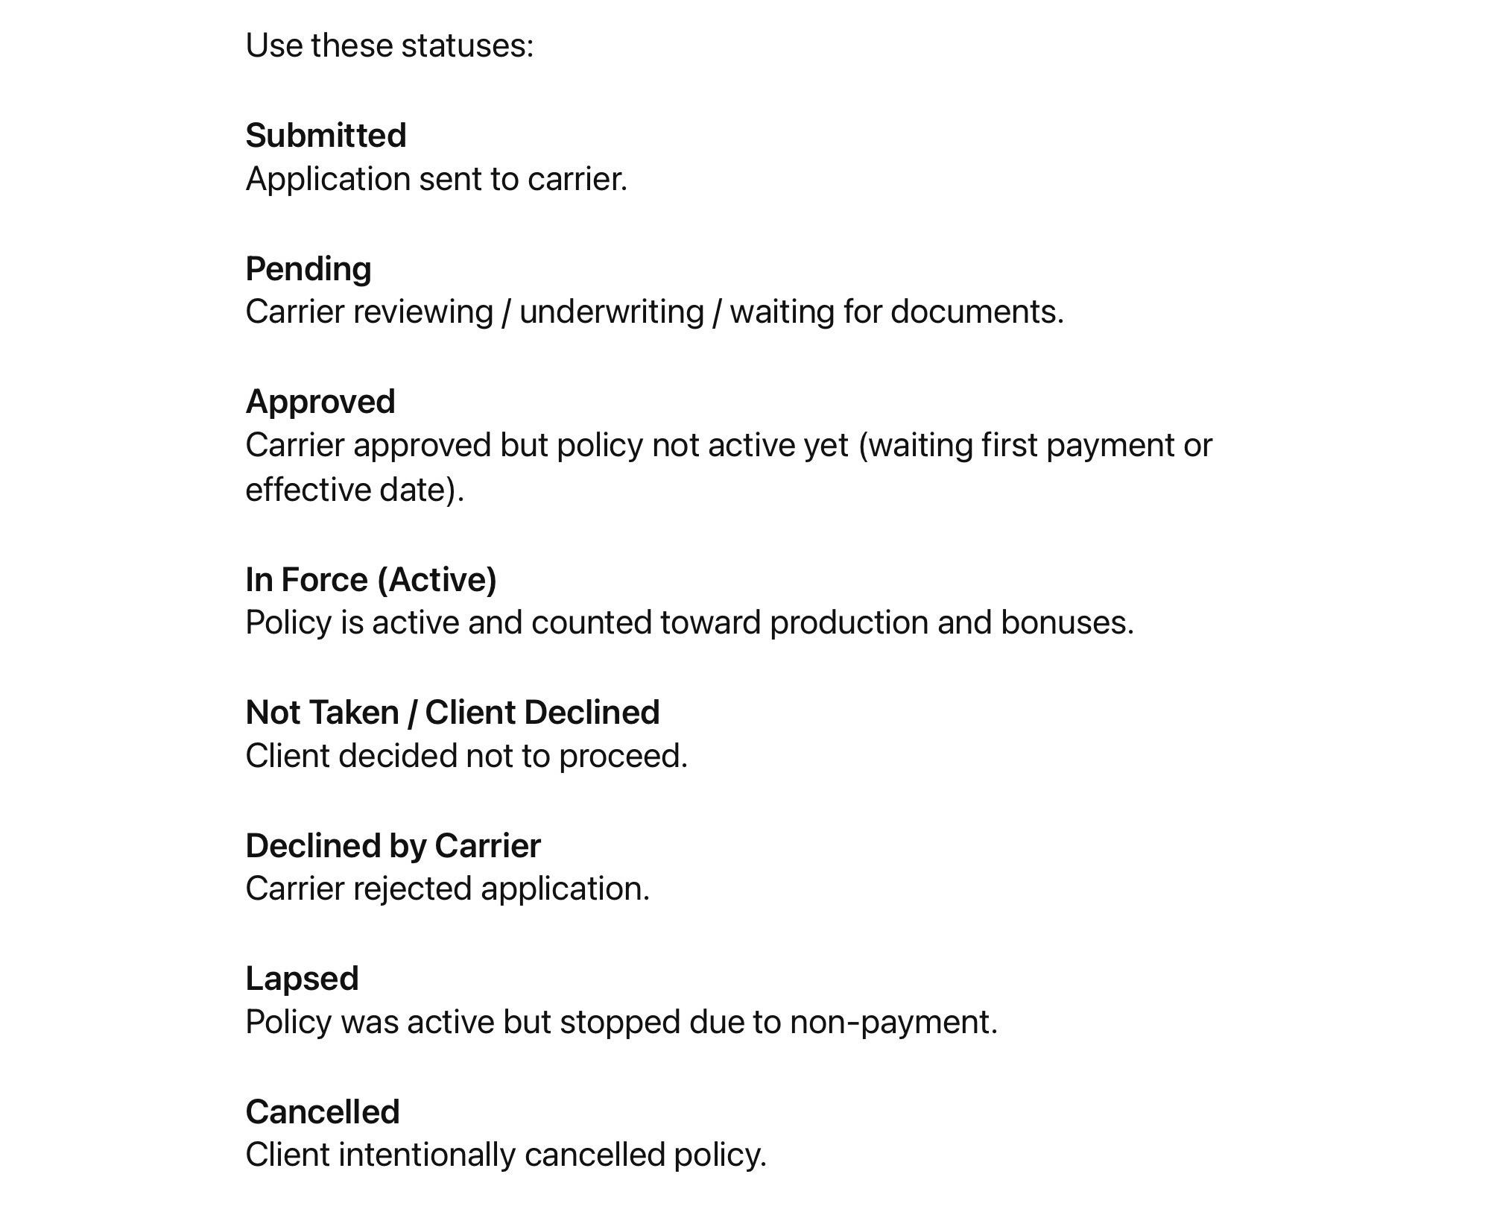
________________________________________________________

6. Vistaprint - Final business card template and vendor link
You need to register in the Vistaprint Affiliate Program. And please provide Vistaprint credentials.
We would be using Redirect Integration with Vistaprint, the idea is simple:
RHP Office website does NOT process the order. We just send users to Vistaprint to complete the purchase and you earn from their affiliate program.

Credentials:
Rhpinsurance@gmail.com
Rhp2026!

Below is a picture of the two designs. One in spanish and one in english. 